# **2023 Quantum Winter School Azure Edu Hub Onboarding Instructions**

In the Quantum Winter School with Microsoft Azure Quantum, we will be using the Azure Education (“Azure Edu”) Hub to provide you an Azure Subscription, which will allow you to run code on the quantum computer simulators and hardware available in Azure Quantum. (As you will see in the course, the simulators and hardware available in Azure Quantum are provided by Microsoft’s partners, [IonQ](https://ionq.com/?gclid=Cj0KCQiAw8OeBhCeARIsAGxWtUwsMUjq-KvUE-vaGdkr0iP4x4KYIYUJgKGdHgN_PlED48b49kfe550aArE2EALw_wcB), [Rigetti](https://www.rigetti.com/), and [Quantinuum](https://www.quantinuum.com/)).

This guide will walk you through how to create, and onboard to, an Azure Edu Hub account, enable your Azure Subscription, and create an Azure Quantum workspace.

Please note that the Azure Subscription granted through the Winter School has a credit limit assigned to it, and is **only to be used for Winter School assignments**. If you use your Azure Subscription for other purposes and exceed the available credit, you will not be able to proceed with the curriculum.

**Step-by–Step Process:**

## Step 1 – Have a Microsoft Account (also referred to as an MSA)

* A Microsoft account (MSA) gives you access to Microsoft products and services with just one login. In order to join the Winter School Azure Edu Hub, you must have an MSA account with the same email that you used to apply for the Quantum Winter School (this will also be the email address that we sent your acceptance email to).
* In the case you do not already have an MSA with that email address, there is no charge and no need to provide a credit card to set one up. Here's how to do it:
* Go to [account.microsoft.com](https://account.microsoft.com/), select **Sign in**, and then choose **Create one!**

## Step 2 – Accept your new Azure Subscription to be used for your class

* Look for an email from Microsoft Azure [azure-noreply@microsoft.com](mailto:azure-noreply@microsoft.com) titled “You’ve been asked to accept Azure subscription ownership.” Again, this email would have been sent to the same email address you used to apply to the Winter School. Please check all folders if you are unable to find it. 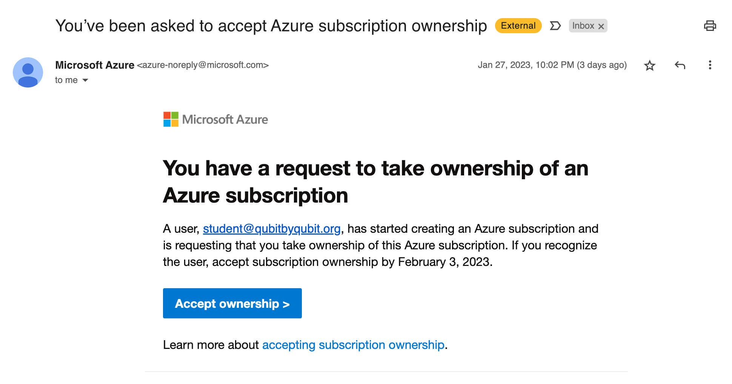
* Click “Accept Ownership”
  + **NOTE:** It does not matter if you have previously created an Azure subscription with the email address you are using - you must still accept this subscription in order to be added into the Quantum Winter School platform.
  + **NOTE:** Before you accept the subscription, please make sure you are signed out of any other Azure accounts (except the one linked to the Winter School).
* Sign in with the MSA you identified/created in Step 1. If you have logged into Azure before using this or another MSA, you may see your previous sign in accounts listed. If you have a few MSAs listed, select the MSA that received your new Azure subscription. If nothing was listed, hit “use another account.”

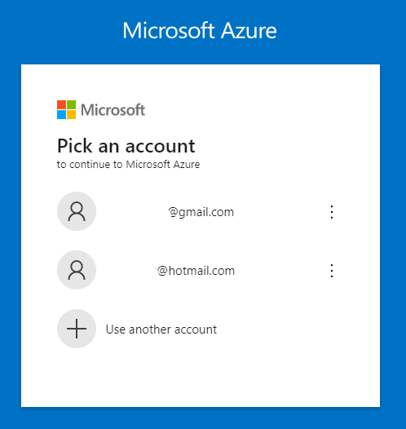

* Once you have successfully logged in to Azure, scroll down on this screen and click accept ownership again.

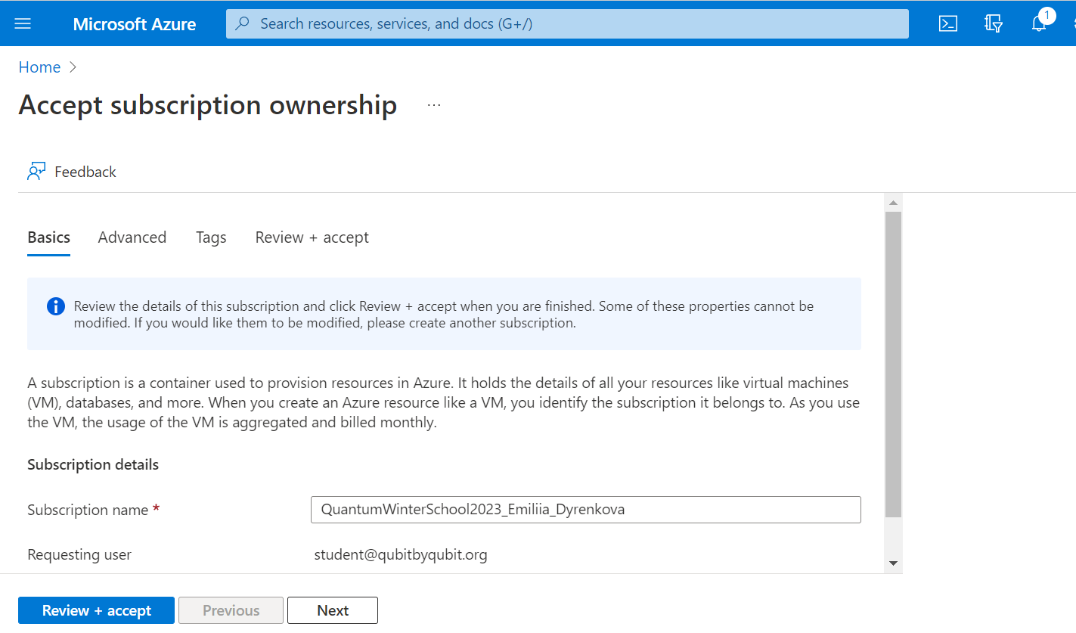

## Step 3 – Launch your new Azure subscription

* Look for a new email from Microsoft Azure [azure-noreply@microsoft.com](mailto:azure-noreply@microsoft.com) titled “Welcome to your new Azure subscription.”

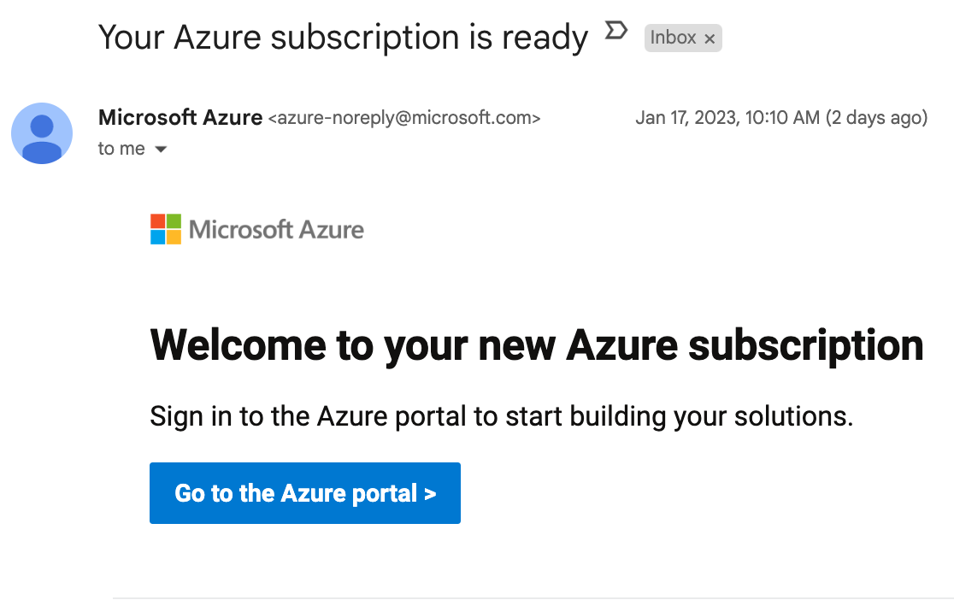

* Click “Go to the Azure portal.”
* With Step 3 complete, you now have a new Azure Subscription dedicated to Winter School!
  + **Please note that you have been granted this Azure Subscription ONLY for use in the Winter School.** You should not use this subscription to deploy any other services before or during the course. The QxQ Team can see if these accounts are being used to deploy services outside the scope of the Winter School, and doing so may result in your termination from the course. In other words, do not start running outside code before the start of the program!

## Step 4 - Create your Azure Quantum Workspace

* With your Winter School Azure Subscription, you now have the ability to create a Quantum Workspace in Azure Quantum. The Quantum Workspace will be used to work on Jupyter Notebook assignments that you will be given during your lab section.
  + **Note:** you may need to wait up to 5 minutes for your subscription to load before continuing with the steps below. Please be patient!

The simple steps are shown below, starting from the “Home” pane in Azure.

* 1. After signing in to Azure using your MSA, Search for “quantum” in the top search bar. Then click “Quantum Workspaces” under “Services.” (It make take a few minutes for you to see this option)   
     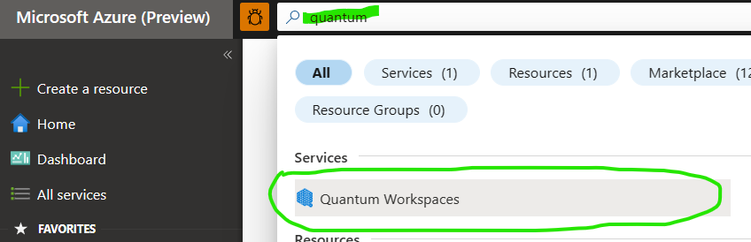
  2. Click “Create a quantum workspace”  
     Screenshot - selecting "Create a Quantum Workspace"
     
  3. Within the “Create a Quantum Workspace” pane, select “Quick Create” option. Note that the Subscription shown should be your Azure subscription created while joining the classroom.  
     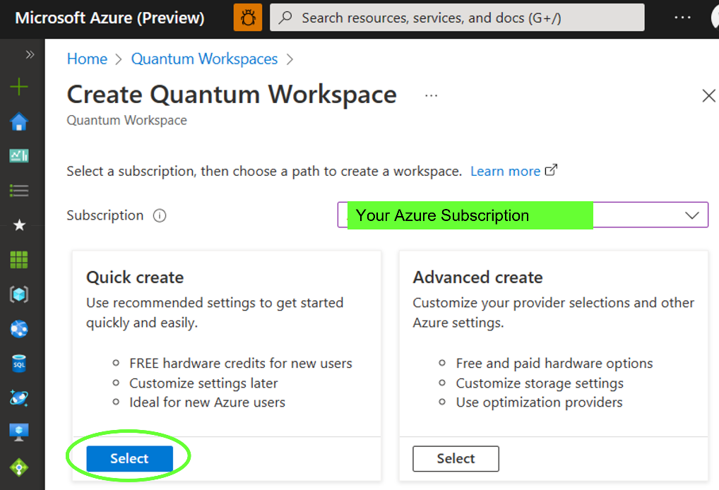
  4. Input your Workspace name. Your workspace name should follow this format: **qxqwinterschoolFirstNameLastName** 
     1. For example, if your name was Jane Smith or John Doe, your Workspace would be called: qxqwinterschoolJaneSmith or qxqwinterschoolJohnDoe
     2. If you have two last names, please include a ‘-’ between your last names.
     3. If you have special characters in your name, Microsoft may not accept them, but you can replace them with the closest character.

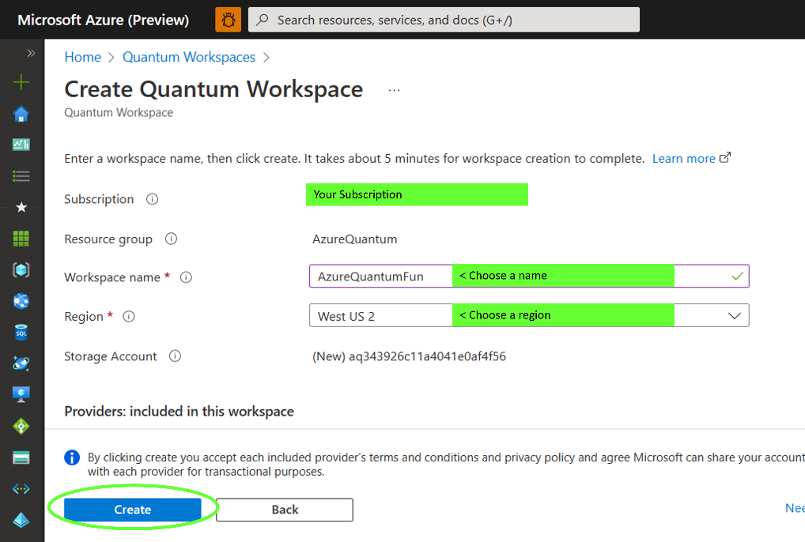

* 1. Choose the Azure region that is closest to your timezone.
  2. When finished click “Create”.
  3. Please be patient! Creating a workspace can take a few minutes. Once complete, you will see a “Your Deployment is Complete” banner. Click “Go to Resource” to be ready to submit your first job using Notebooks. Again, please be patient!   
     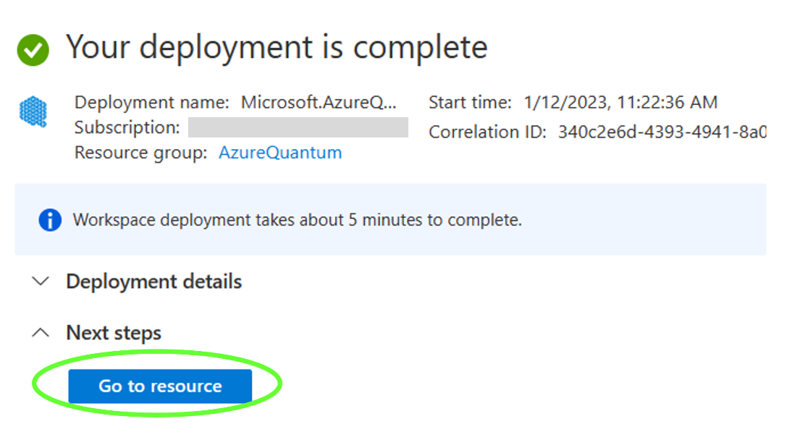
  4. **As a reminder, please make sure you are only using your Quantum Workspace for assignments given to you during the Winter School.**

## Step 5 – Upload a sample notebook

* Under “Operations” on the left navigation pane, click “Notebooks”. Then select “My Notebooks,” then “Upload Notebooks,” and upload this [dummy assignment Notebook](https://drive.google.com/file/d/1VNasRSi945qitiPoE2JInbPY7LSWYY_r/view).

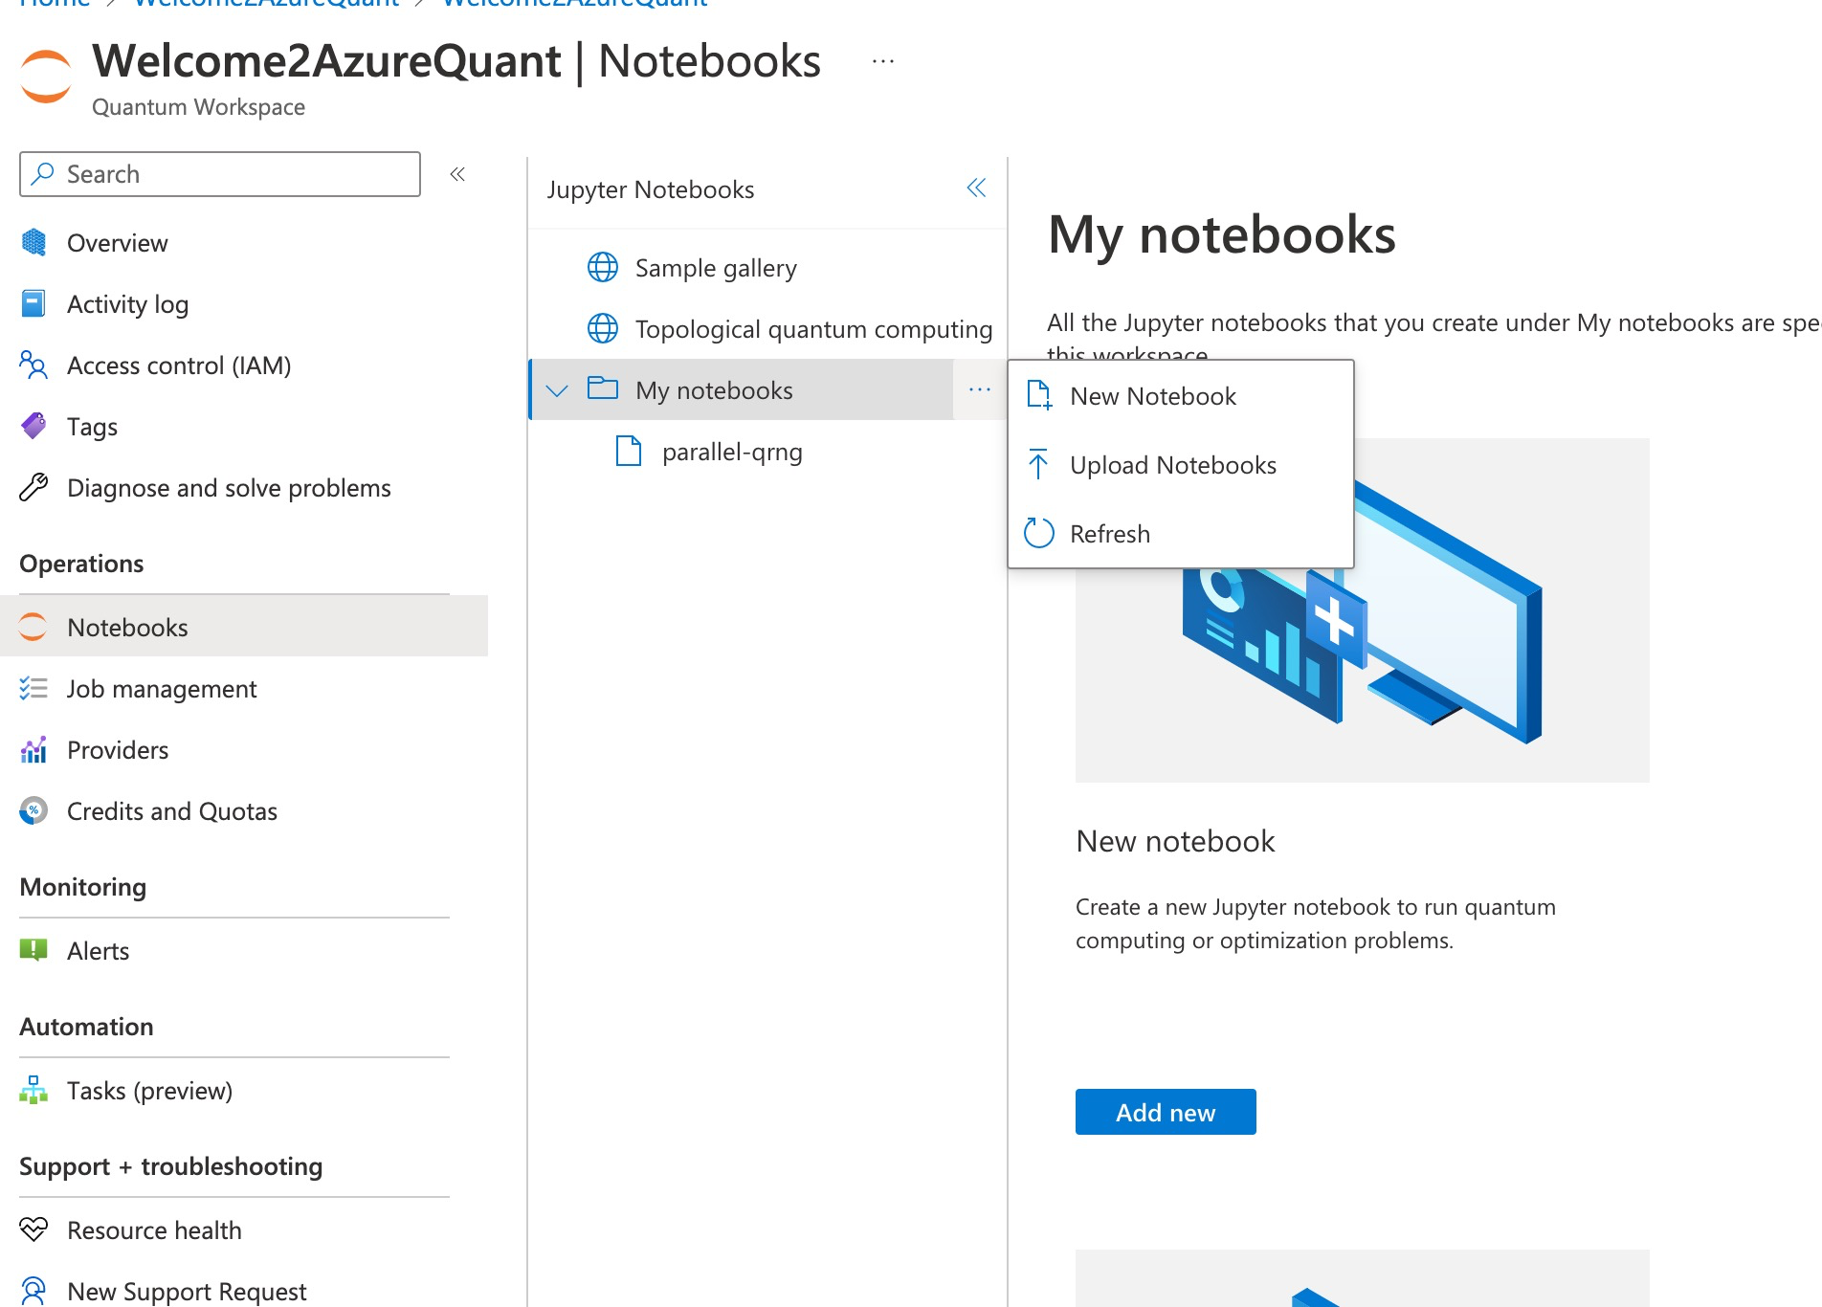

## Step 6 – Wait for further instructions from the QxQ Team for how to do assignments with Azure Quantum

* Now that you have created your own Quantum Workspace and uploaded a sample notebook, you are ready to go for the Winter School! Don’t worry about letting us know that you have finished onboarding - the QxQ Team will be able to see this on the backend. Within ~24 hours after onboarding, you will receive an email from us containing your lab assignment and its Zoom link.
* Once class starts, we will provide additional instructions on how to access assignments and work on them in the Quantum Workspace using Notebooks.

**NOTE:** You will not have the individual course Notebooks for class before the start of the Winter School. Each day of the program, we will be updating the “Course Calendar, Outline, and Materials” section of the Student Handbook with links to the materials you will need that day.